Construction Site Erosion and Sediment BMPs

Important information from: $$Insert Municipality Name & Department$$
Stormwater Best Management Practices

Construction projects, including new development and redevelopment of buildings and facilities, run the risk of introducing pollutants such as oils, chemicals, and metals into the surrounding lakes, ponds, rivers, and streams (generally known as waterbodies).
Another large source of pollutants associated with construction projects comes from the sediment that is disturbed during construction and then exposed to rain and snowmelt. This sediment can contain nutrients such as phosphorus and nitrogen which can be harmful to a waterbody.
As rain and snowmelt (more generally called stormwater), flows over the exposed sediment, picking up the nutrients within it, along with any other pollutants it flows across. The stormwater carries nutrients directly into waterbodies or into storm drains, which then discharge untreated stormwater and pollutants into the waterbody. These pollutants can then cause unintended harm to the water quality and life within the waterbody.
There are a multitude of best management practices (BMPs) that can be used to eliminate or reduce the amount of pollutants in stormwater leaving a construction site, which in turn helps to reduce the amount of pollutants deposited in local waterbodies.
BMP Selection, Installation, and Maintenance
Selecting a BMP:
- When selecting and installing BMPs at a construction site, it is important to select the appropriate BMP for addressing site specific concerns. For example, having a gravel construction entrance to help reduce the amount of sediment tracked out of a site might work well for a site with minimal exposed soils but not for a site with large areas of exposed soils.
- The Environmental Protection Agency (EPA) has fact sheets explaining many of the common construction site BMPs. The fact sheets contain information on how to design, install, and maintain each of the BMPs. Fact Sheets can be found on EPA’s website
at https://www.epa.gov/npdes/national-menu-best-management-practices-bmps-stormwater-construction.
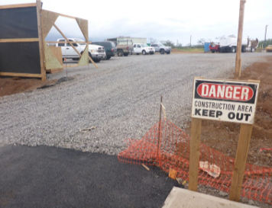
Installing a BMP:
- The installation of BMPs should follow the manufacturer’s instructions to ensure that the BMPs function properly and reduce the largest amount of pollutants possible.
- The incorrect installation of BMPs can result in an increased amount of pollutants flowing into local waterbodies, and in some cases, complete failure of the BMP which costs both time and money to repair or replace. For example, when installing a silt fence, it is important to bury the bottom of the fence to prevent water from flowing directly under, allowing sediment and pollutants to escape.
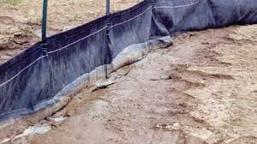
BMP Inspections and Maintenance:
- To ensure that installed BMPs continue to function properly and reduce pollutant runoff and erosion, they should be inspected frequently. Inspections should take place weekly as well as during or after storm events. If large amounts of rain are received, inspections should be conducted more frequently to ensure that the BMPs have not been damaged or failed.
- If during inspections it is found that any BMPs have become damaged or have failed, steps should be taken as soon as possible to repair or replace the BMP.
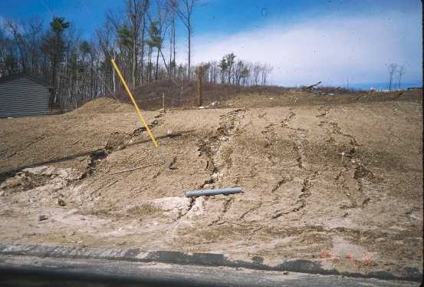
$$Insert Municipality Name or Logo Here$$
As part of the USEPA’s 2017 National Pollutant Discharge Elimination Systems (NPDES) General Permit for Stormwater Discharges from Small Municipal Separate Storm Sewer Systems (MS4) in New Hampshire, $$Insert Municipality Name$$ is required to educate construction operators on pollution prevention. This fact sheet is intended to fulfill permit requirements.

