2017 New Hampshire Small MS4 General Permit
New Hampshire Stormwater Coalitions Year 5 Annual Report Templates Guidance Document

- How do I Remove Instructions and Important Notes Written in Red Text?
Instructions and important notes have been added to both the New Hampshire Stormwater Coalitions Year 5 “Existing Permittee” and “New Permittee” Annual Report templates to help permittees better understand what needs to be reported for each of the associated requirements. All the instructions and important notes language in both versions of the NH Year 5 Annual Report templates are noted in red text to draw attention and to help differentiate it from the required information in the Annual Report. Once the permittee has completed the Annual Report, they should remove all the instructions and important notes in red text and any of the associated text boxes that might have been surrounding the instructions and important notes. To help permittees understand what should be removed and how to remove it correctly, please use the following directions.

- Locate the instructions and important notes in red text you would like to delete.
Example:
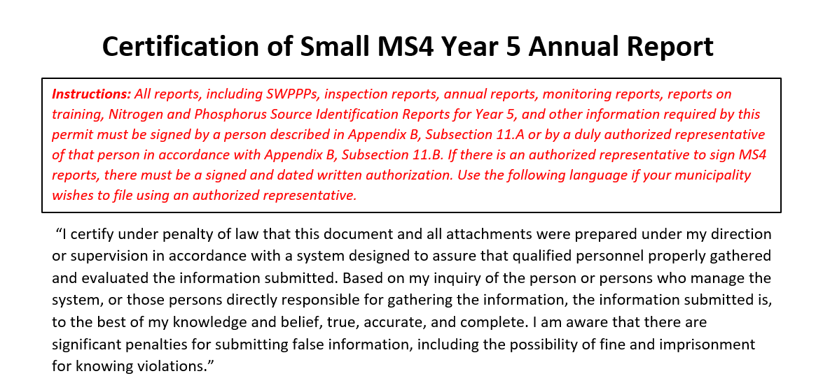

Instructions (Items #2 - #5)
- For instructions that contain a box, select the box, if there is one, around the instructions and important notes in red text that you would like to delete. This is done by just clicking on the lines of the box itself. It might take a few clicks to actually select the box. Once the box it selected, small white dotes along with a few other icons should appear around the box.
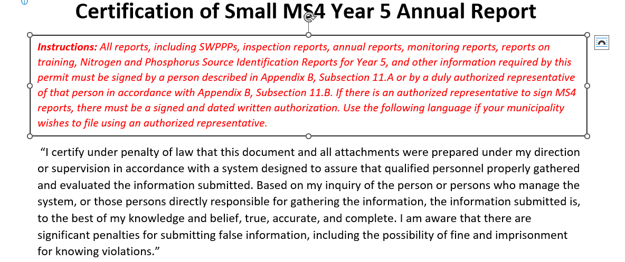

- Once the box is selected, press the delete button. This will then leave just the instructions and important notes in red text.
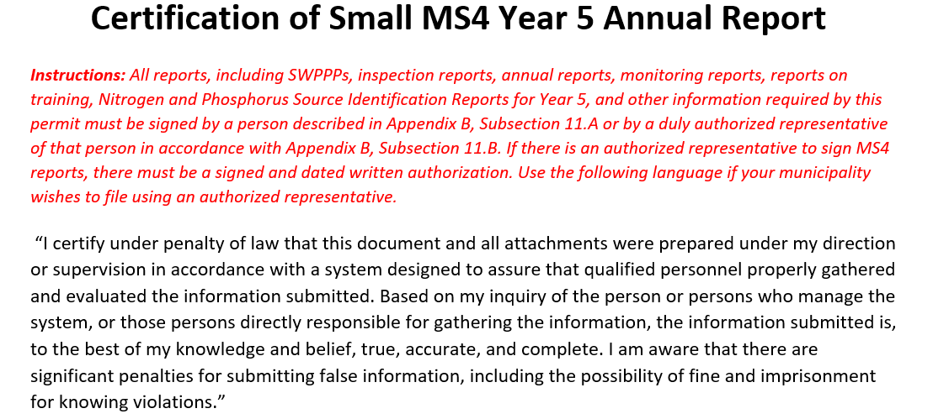

- Lastly, highlight all of the instructions and important notes in red text you want to remove, and press delete.
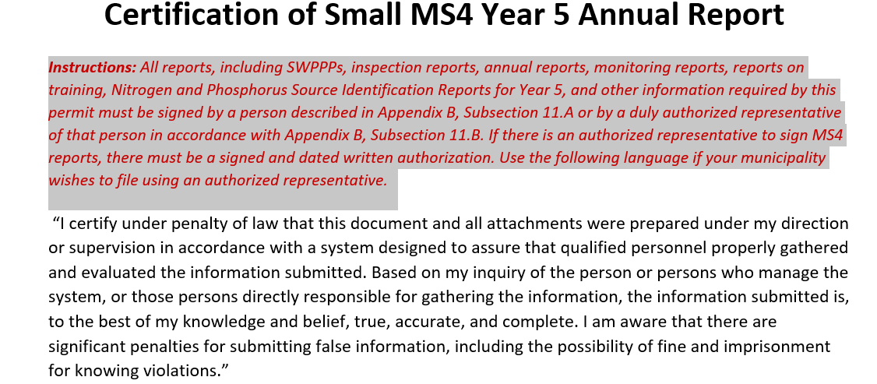

- The section should no longer have any instructions and important notes in red text and will appear as noted below.
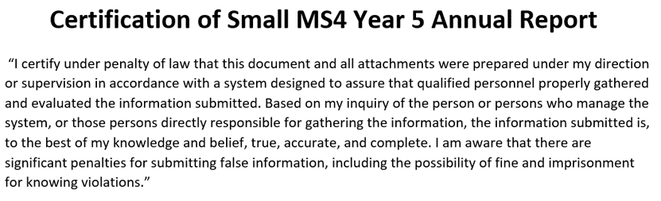

- Removing Important Notes that contain Red Text with Columns
Within the New Hampshire Stormwater Coalitions Year 5 “Current Permittee” and “New Permittee” Annual Report templates there are important notes identified in red text and associated boxes with lists of relevant permittees in different columns. The permittees were listed in columns to save space within the NH Year 5 Annual Report templates. There is an additional step that must be taken before the important notes in red text and boxes can be deleted.
Example
- Locate the important notes in red text with columns you would like to delete.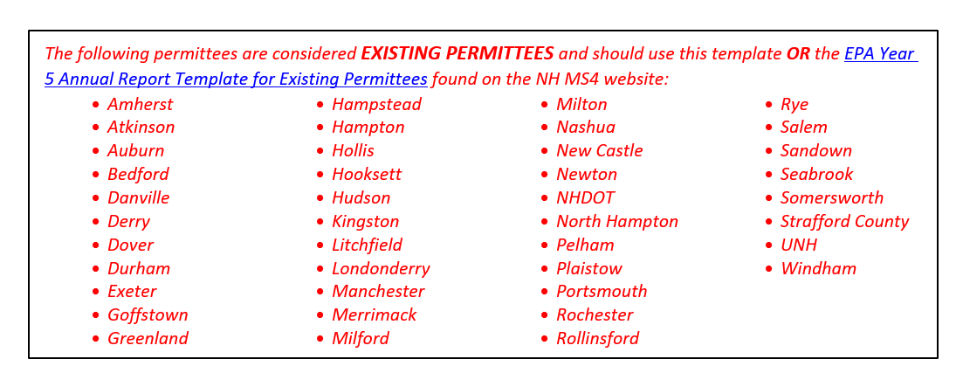

Instructions (Items #2 - #5)
- Highlight all of the red text in the columns.
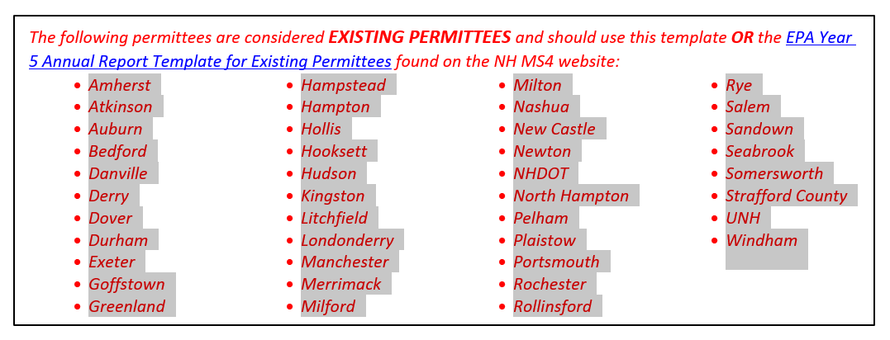

- Go to the “Layout” tab of Microsoft Word and then locate the “Columns” option under the “Page Setup”.
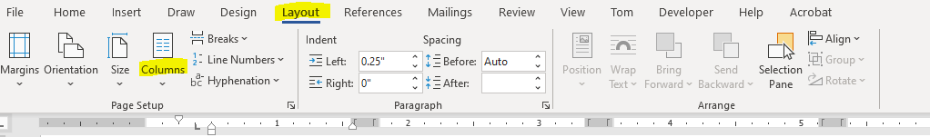

- With the red text still highlighted, press the “Columns” option, and select “One” from the dropdown list.
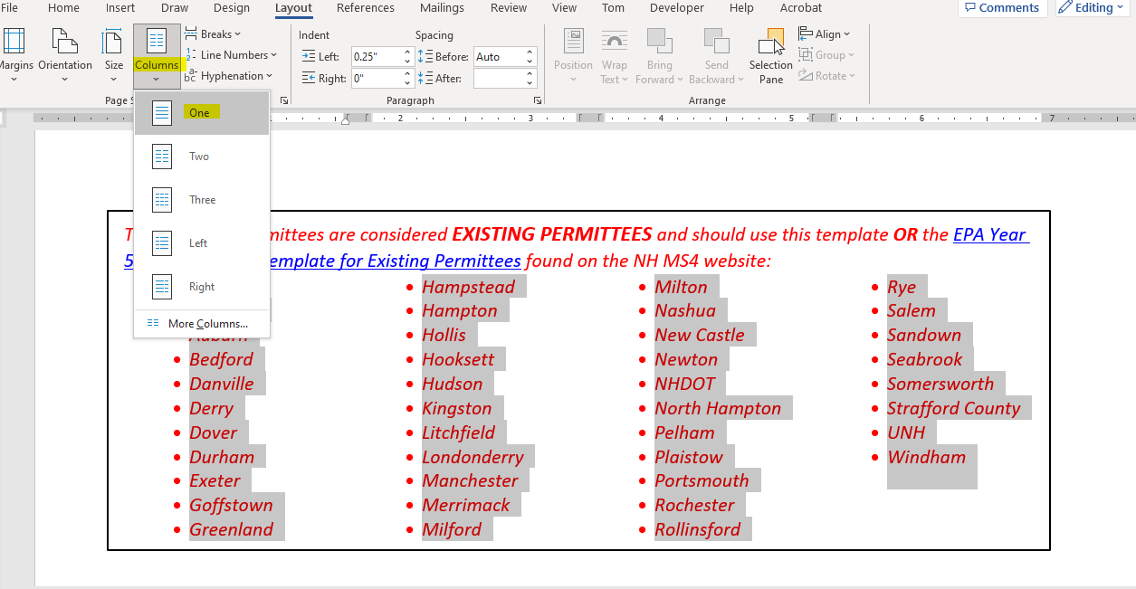

- The list of permittees will then appear as a single column and the red important notes text and associated box can be deleted following the instructions above.
