Stormwater Pollution Control for Industrial Facilities

Important information from: $$Insert Municipality Name & Department$$
Keeping pollutants out of the drainage system
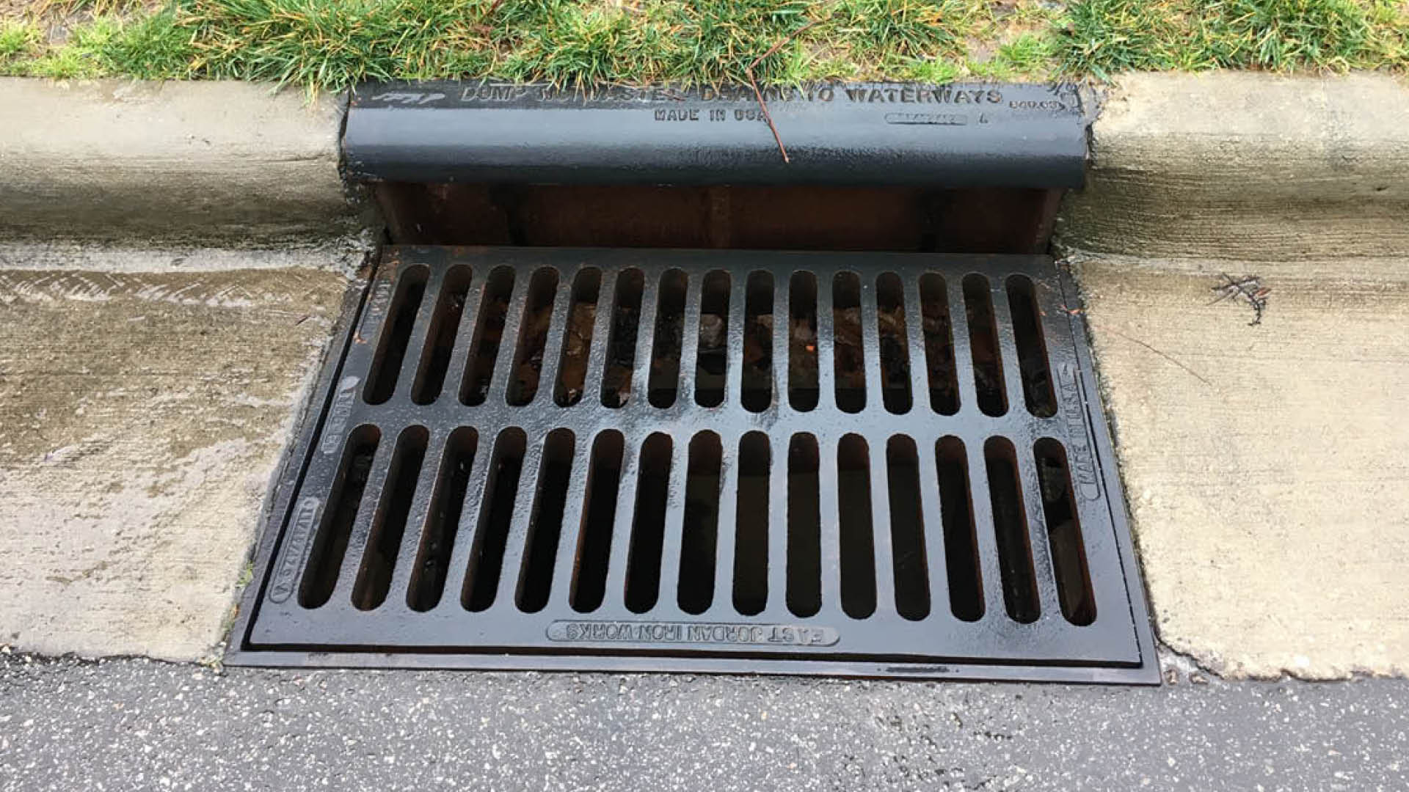

Material handling and storage, equipment maintenance and cleaning, and other activities at industrial facilities are often exposed to the weather. Stormwater runoff from rain or snowmelt that comes in contact with these activities can pick up pollutants, and transport them directly, or indirectly through the $$name of town or city$$’s storm drains which flow untreated into nearby waterbodies and degrade water quality. Pollutants harm fish and wildlife, make our water unsafe to drink, and can impact recreational use of waters.

You are responsible for pollutants that leave your property

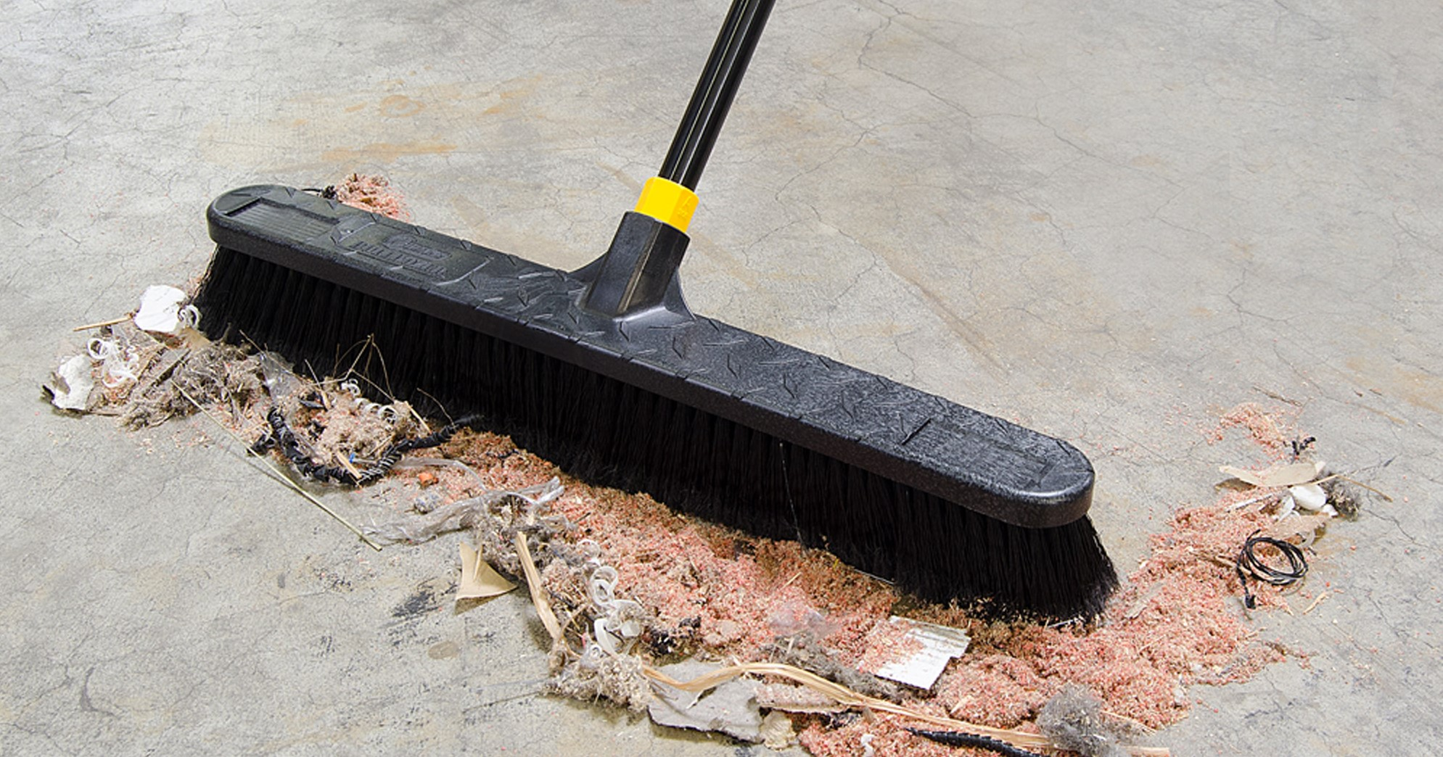As an industry owner or operator, you are responsible for all pollutants that leave your property. Where possible, minimize or prevent exposure of pollutants to stormwater by following these tips:
- Cleaning: Maintain an orderly facility. Sweep paved driveways, parking lots, and storage areas regularly.
- Maintenance: Perform vehicle and equipment maintenance and repair indoors or off site. Inspect vehicles and equipment for leaks regularly.
- Washing: Perform cleaning of equipment and/or vehicles on impervious surfaces with drains piped to the sanitary sewer or a tight tank.
- Storage: Store all materials, products, and waste indoors in covered, sealed, labeled containers. Storage area should be dry, cool, well-ventilated, and insulated.
- Spill Prevention: Develop spill prevention and response procedures. Check storage areas often for leaks and spills. Equip storage areas with easily accessible spill cleanup kits. Immediately clean-up spills and report as appropriate.
- Disposal: Don’t dump excess, outdated, or waste materials in drains. Dispose of them according to the manufacturer’s instructions and local
regulations. Designate waste disposal areas.
- Infiltration: Encourage infiltration of stormwater runoff (e.g., from roof drains) into soil to prevent it from flowing across exposed areas.
- Training: Conduct annual employee training on stormwater pollution prevention and spill response.
EPA REQUIREMENTS:
Your industrial facility may require a Multi-Sector General Permit (MSGP). The MSGP requires operators of certain industrial facilities to develop a Stormwater Pollution Prevention Plan (SWPPP). To learn more, visit EPA’s website at: https://www.epa.gov/npdes/stormwater-discharges-industrial-activities.
2021 MSGP monitoring changes
In 2021, a new version of the MSGP was released by EPA. This new version of the permit has several changes including the following monitoring requirements:
- Indicator monitoring for Polycyclic Aromatic Hydrocarbons (PAHs), pH, Total Suspended Solids (TSS), and Chemical Oxygen Demand (COD)
- Updated benchmark thresholds and monitoring schedules

- Monitoring of impaired waters
- The monitoring requirements listed above vary depending on the type of industry sector that an organization falls under. To see the requirements for each of the industry sectors, please see the EPA MSGP located here: https://www.epa.gov/npdes/stormwater-discharges-industrial-activities-epas-2021-msgp
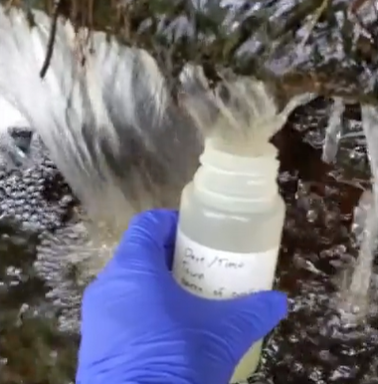
$$Insert Municipality Name or Logo Here$$ | As part of the USEPA’s 2017 National Pollutant Discharge Elimination Systems (NPDES) general Permit for Stormwater Discharges from Small Municipal Separate Storm Sewer Systems (MS4) in New Hampshire, $$Insert Municipality Name$$ is required to educate industrial facilities on pollution prevention. This fact sheet is intended to fulfill permit requirements.

