Winter Maintenance Social Media Posts

For homeowners:

As the colder season begins, it’s important to make sure that winter salt being applied to our driveways is being used in an environmentally safe way. Companies that are certified Green SnowPro professionals are trained to remove snow and ice using practices that keep both the public and the environment safe. To find a list of Green SnowPro certified contractors, go to https://www.des.nh.gov/sites/g/files/ehbemt341/files/documents/cert-salt-applicators.xls

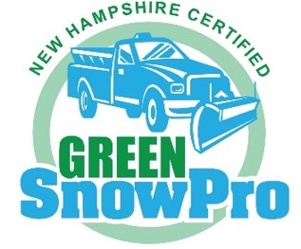

For businesses:

Does your business handle snow and ice removal? Have you heard about the Green SnowPro Program? Companies that are certified under this voluntary program receive liability protection against damages arising from snow and ice conditions. They complete comprehensive coursework to learn best snow and ice management practices to keep both the public and the environment safe. To find out more about the Green SnowPro Program visit https://www.des.nh.gov/land/roads/road-salt-reduction/green-snowpro-certification

