A screenshot of the Hach Nitrate and Nitrite Test Strips Webpage. The page can be found here: https://www.hach.com/nitrate-and-nitrite-test-strips/product-details?id=7640211606


LOT# 2842A

Expiration Date: 2020/12

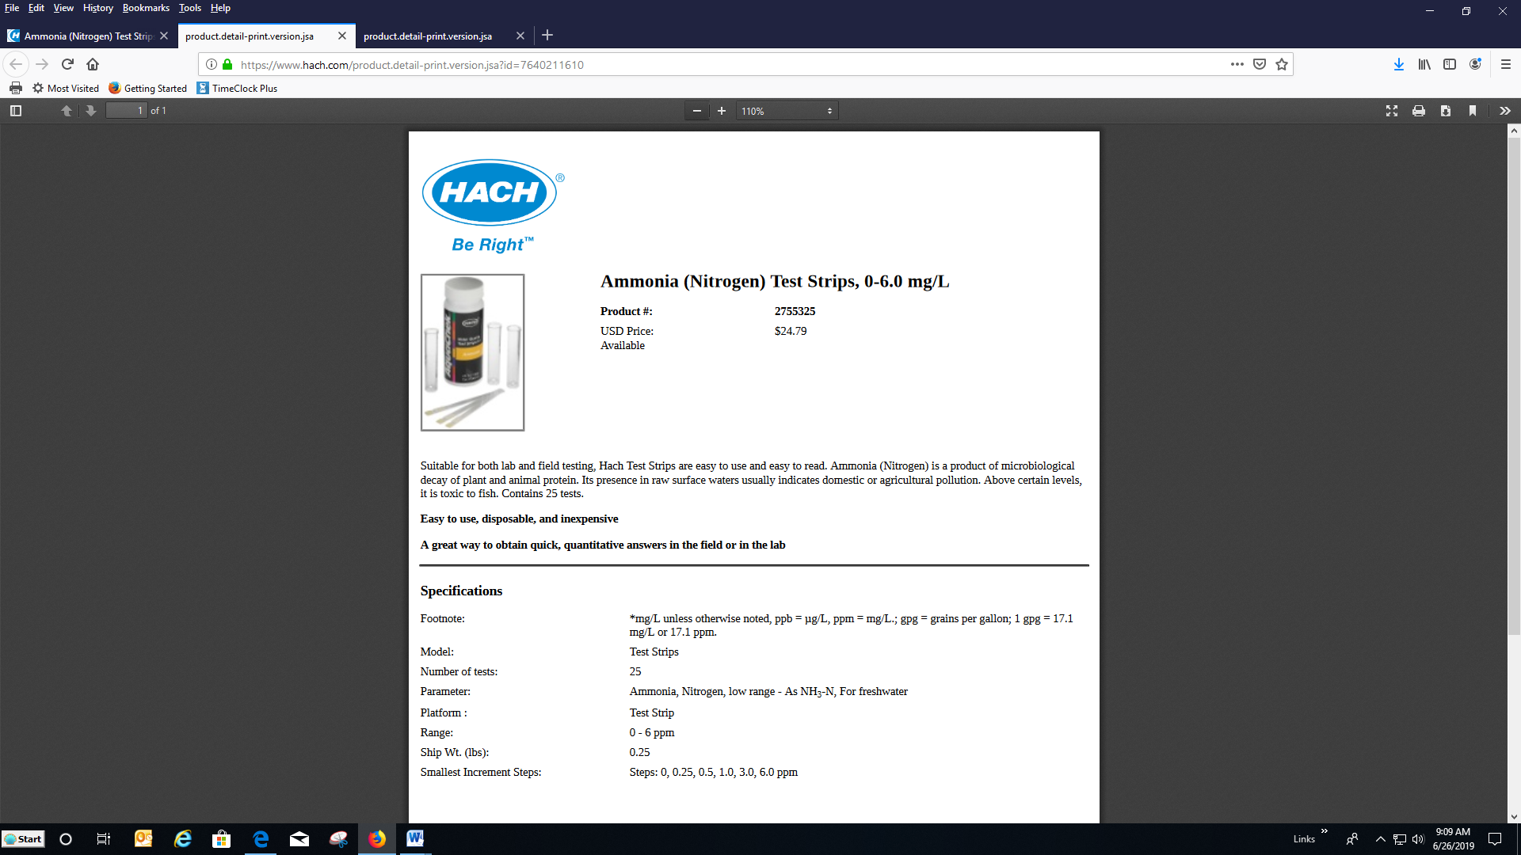

LOT# 2843A

Expiration Date: 2021/04

A screenshot of the Hach Total Chlorine Color Disc Text Kit, Model CN-66T Webpage. The page can be found here: 
https://www.hach.com/total-chlorine-color-disc-test-kit-model-cn-66t/product?id=7640219521

LOT# 2841A

Expiration Date: Apr-24 (original packets)

A screenshot of the Hach Phosphorous (reactive and Total) TNTplus Vial Test, LR (0.15-4.50 mg/L PO4), 25 Tests Webpage.
The page can be found here: 
https://www.hach.com/phosphorus-reactive-and-total-tntplus-vial-test-lr-0-15-4-50-mg-l-po-25-tests/product?id=7640196815

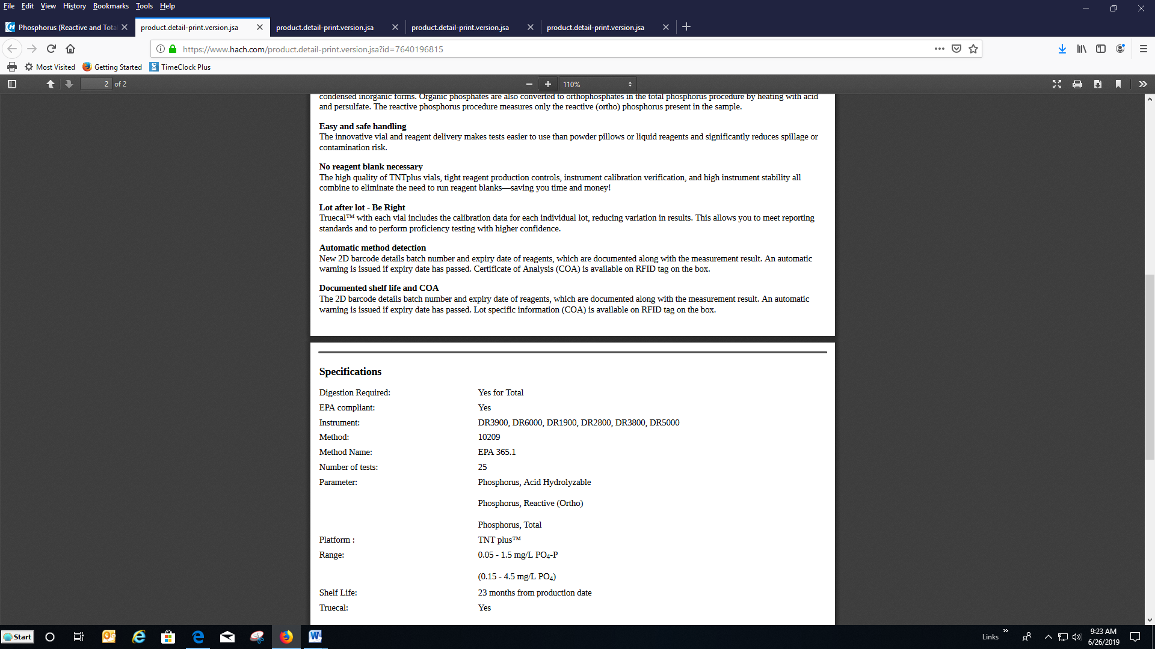

Digestion Required: Yes for Total
EPA compliant: Yes
Instrument:
DR3900, DR6000, DR1900, DR2800, DR3800, DR5000
Method: 10209
Method Name: EPA 365.1
Number of tests: 25
Parameter: Phosphorus, Acid Hydrolyzable, Phosphorus, Reactive (Ortho), Phosphorus, Total
Platform : TNT plus™
Range: 0.05 - 1.5 mg/L PO₄-P
(1.5 mg/L-4.5 mg/L PO₄
Shelf Life: 23 months from production date
Truecal: Yes

LOT# 2844A

Expiration Date: 3/28/21

A screenshot of the Hach Pocket Pro Salinity Tester Webpage.
The page can be found here: 
https://www.hach.com/pocket-pro-salinity-tester/product?id=17990686208

LOT# 2847A

A screenshot of the Hach Singlet Single-use Conductivity Standard Solution, 18.22 mS/cm, KCl, 20 mL Webpage.
The page can be found here: 
https://www.hach.com/singlet-single-use-conductivity-standard-solution-12-88-ms-cm-kcl-20-ml/product?id=16185050304

Expiration Date: 24 month shelf life, discard after use

A screenshot of the Sper Scientific Direct Large Display pH Pens- 850050,51,52 Webpage.
The page can be found here: https://www.weberscientific.com/waterproof-large-display-ph-pen-sper-scientific

A screenshot of the Sper Scientific Direct Large Display pH Pens- 850050,51,52 Webpage.
The page can be found here: https://www.weberscientific.com/waterproof-large-display-ph-pen-sper-scientificA screenshot of the Sper Scientific Direct Large Display pH Pens- 850050,51,52 Webpage.
The page can be found here: https://www.weberscientific.com/waterproof-large-display-ph-pen-sper-scientific

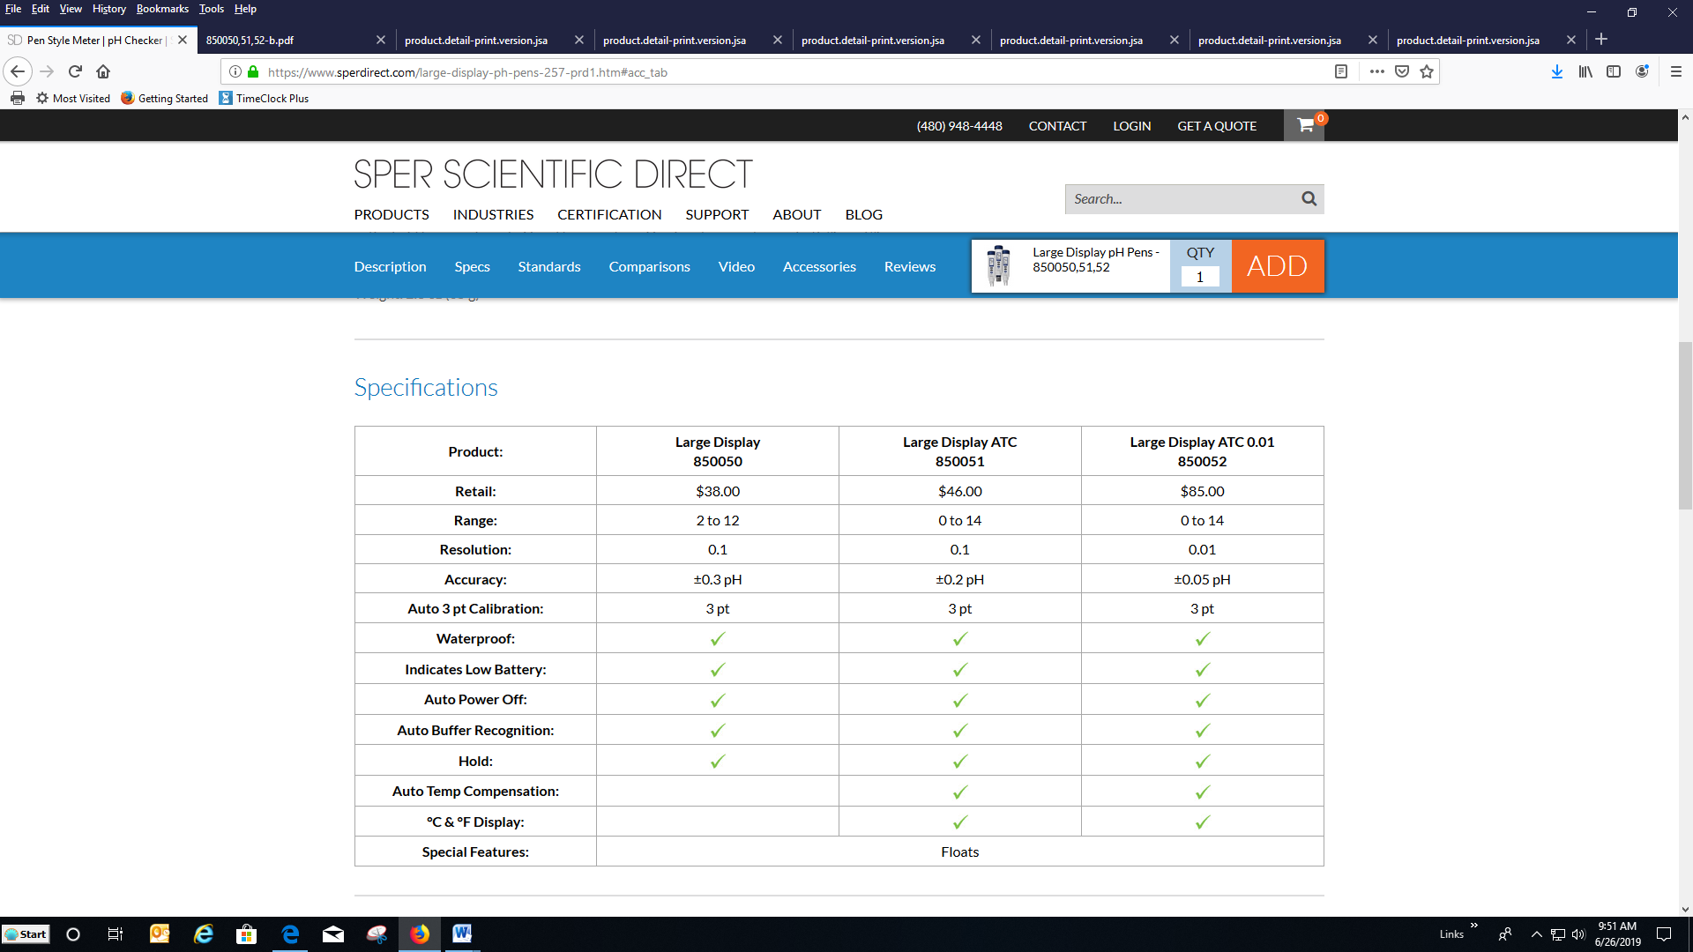A screenshot of the Sper Scientific Direct Large Display pH Pens- 850050,51,52 Webpage.
The page can be found here: https://www.weberscientific.com/waterproof-large-display-ph-pen-sper-scientific

LOT #2753A

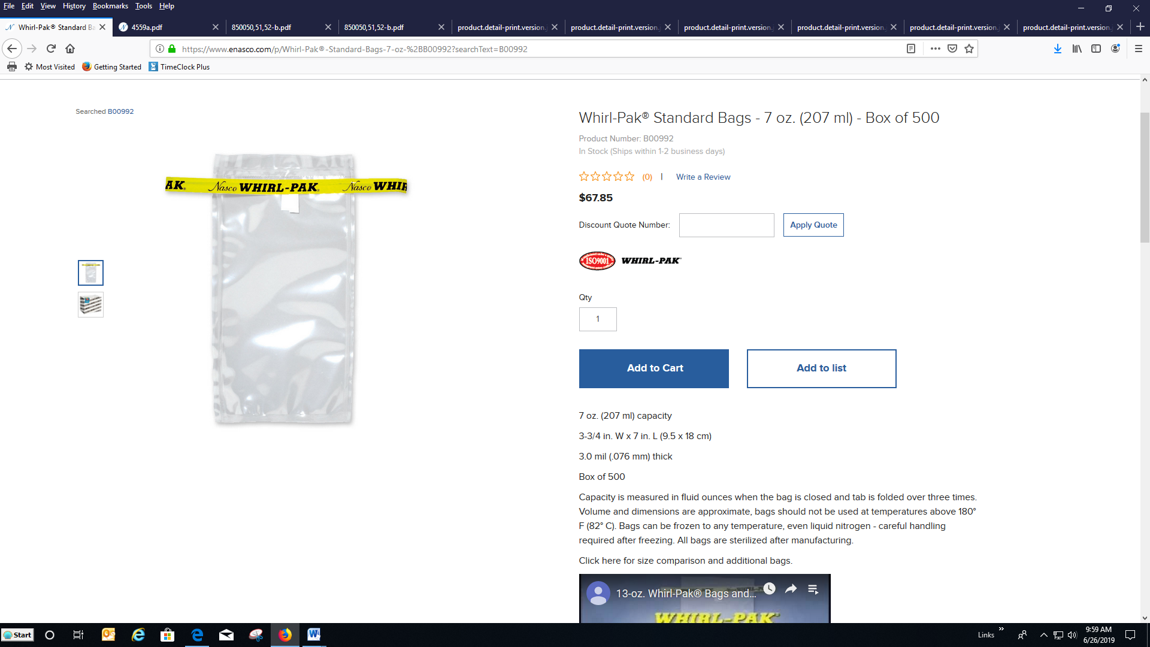



A screenshot of the specifics of the Whirl-Pak Bags:
7-oz. (207 ml), 3¾” W x 7” L (9.5 x 18 cm).
Film Thickness: 3 mils (.076 mils).
Box of 500.

LOT# 1791A

A screenshot of the Hach HQ40D Portable Multi Meter pH, Conductivity, Salinity, TDS, Dissolved Oxygen (DO), ORP and ISE For Water Webpage.
The page can be found here: 

https://www.hach.com/hq40d-portable-multi-meter-ph-conductivity-salinity-tds-dissolved-oxygen-do-orp-and-ise-for-water/product?id=7640501639


A screenshot of the Hach HQ40D Portable Multi Meter pH, Conductivity, Salinity, TDS, Dissolved Oxygen (DO), ORP and ISE For Water Webpage.
The page can be found here: 

https://www.hach.com/hq40d-portable-multi-meter-ph-conductivity-salinity-tds-dissolved-oxygen-do-orp-and-ise-for-water/product?id=7640501639


A screenshot of the Hach HQ40D Portable Multi Meter pH, Conductivity, Salinity, TDS, Dissolved Oxygen (DO), ORP and ISE For Water Webpage.
The page can be found here: 

https://www.hach.com/hq40d-portable-multi-meter-ph-conductivity-salinity-tds-dissolved-oxygen-do-orp-and-ise-for-water/product?id=7640501639


A screenshot of the Hach IntelliCAL LDO101 Field Luminescent/Optical Dissolved Oxygen (DO) Sensor, 5 m Cable Webpage.
The page can be found here: https://www.hach.com/intellical-ldo101-field-luminescent-optical-dissolved-oxygen-do-sensor-5-m-cable/product?id=7640489865




A screenshot of the Hach IntelliCAL LDO101 Field Luminescent/Optical Dissolved Oxygen (DO) Sensor, 5 m Cable Webpage.
The page can be found here: https://www.hach.com/intellical-ldo101-field-luminescent-optical-dissolved-oxygen-do-sensor-5-m-cable/product?id=7640489865


