UNH DRY WEATHER SAMPLING PROCEDURES & EQUIPMENT LIST (DRAFT)
UPDATED December 2019:
The parameters outlined in the MS4 permit cannot all be tested using a single piece of equipment, so a set of equipment and materials was assembled to meet these requirements.
Sample Requirements:
- Ammonia
- Chlorine
- Conductivity
- Salinity
- E.coli
- Surfactants
- Temperature
- Pollutants of concern (phosphate, nitrate)

YSI ProPlus

Analyte
Temperature
Conductivity (sp Cond)
Salinity
DO
pH
Ammonium
Chloride
Nitrate

Chlorine vs Chloride
Chlorine: The greenish-yellow, highly reactive and diatomic gas that is almost never found free in nature by itself. Most Chlorine is commercially produced and is most widely known for being used within compounds to purify water and create cleaning products.
Chloride: The negatively charged ionic form of Chlorine. Since Chlorine is found deep within the Earth's crust, and is extremely reactive, the only way it can be found in nature is when it reacts with other chemicals and creates compounds. Chloride is what is created when Chlorine gains an electron and combines with other elements. Chloride is found abundantly in nature and is most commonly known for forming neutral salts such as sodium chloride (table salt), potassium chloride, and calcium chloride.
Ammonia vs Ammonium
If the sample temperature and sample pH are known, the below table can be used to determine what percentage of total ammonia is in the ammonia (NH 3) form. This percentage in decimal form can be multiplied by the total ammonia of the sample to calculate the NH 3 form ammonia.
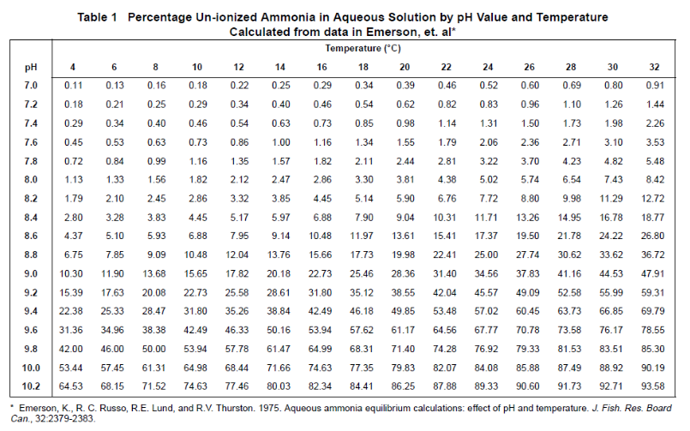

E. coli and Enterococcus

The Quanti-tray sealer by IDEXX was quoted at $4700.50
IVYX Lab Incubator cost = $300
Presence or absence
Secondary sampling using UNH
Surfactants
- CHEMets® Visual Kit for Detergents
- CHEMetrics® SAM Single Analyte Photometer for Detergents
Phosphate
Hach 224800 O-Phosphate Color Disc Test Kit

Costs:
