Water Quality Friendly Lawn Care
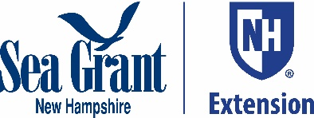
Spring 2020

Julia Peterson, New Hampshire Sea Grant and UNH Cooperative Extension
Instructions:
- Good for short blogs or other social media or press
- Pick appropriate Tip or Tips and cut and paste and add title. Logo, and author reference above
- Delete MS4 topic reference
- Paste onto website or blog or other method
Thinking about working on the lawn or digging in the garden? Whether you are looking to enjoy more time outside or engage your children in a project, this season is a great time to develop some new habits that will improve your green thumb, help protect the environment, and save money. Whatever we do in our yards affects lakes, rivers, streams and bays downhill. By adopting a few simple practices, we can protect the health of water bodies we love while taking care of ourselves and the people around us.
1. Take caution with spring clean up
One of the first activities drawing us outside in the spring is tidying up the accumulation of twigs, pine needles, and decaying leaves left behind during the winter. As this plant material decomposes, it releases nutrients, so there’s no need to aim for immaculate, but important to let the sunlight through. The bulk of the raked-up yard waste should be put in an area where it can compost away from any drainage area or water body. NEVER, rake yard waste into a stormdrain, down a river bank, or adjacent to any water body. Excess nutrients in a water body lead to algae blooms that rob aquatic and marine animals of oxygen, obscure water clarity, and even decrease adjacent property values. Learn more about composting here: https://extension.unh.edu/resource/composting-home-gardener-fact-sheet
Other temptations in the spring include fertilizing too early and mowing too short. Different formulations of fertilizer require different minimum temperatures. Hold off on applying until you are sure your soil needs it and the soil temperature is adequate. Likewise, resist the temptation to mow too low. Encourage the early season grass roots to grow deeper into the soil by keeping more of the grass blade growing above ground.
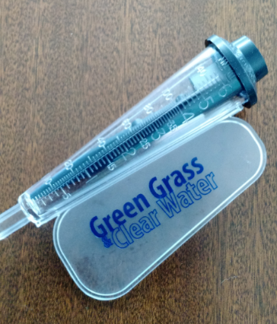
2. Water wisely
Our lawns and gardens need about one inch of water per week, which is about the annual average amount of rainfall in northern New England. During dry spells, especially later in the summer, it may be necessary to water or irrigate to reach that amount. On the other hand, overwatering wastes water and can cause nutrients needed by plants to run off the property or leach deep into the soil out of reach of plant roots. Place a rain gauge or empty bean or tuna can out in the yard and check it weekly to see if the rain has reached a one inch mark. Only water or irrigate when the rainfall drops below that one inch weekly average. Learn more about watering wisely here: https://extension.unh.edu/blog/water-conservation-fundamentals-gardening-and-landscaping
3. Do a soil test
Soil test results provide important information about nutrient and mineral levels in our soil, characteristics of the soil, and recommendations for fertilizer. Without this information, we may end up applying products or using practices that waste time and money, inhibit plant growth and contribute to pollution. Watch a short video about how to take a soil sample and learn more about soil testing here: https://extension.unh.edu/tags/test-your-soil
4. Measure the dimensions of your yard
Whether you are interested in overseeding a lawn, adjusting the soil pH with lime, top dressing with compost, or applying fertilizer, you will need to know the dimensions of the lawn area in order to purchase and/or apply the correct amount of seed, lime, compost, or fertilizer. Overapplying compost or fertilizer, in particular, can create water quality problems in lakes, rivers, and bays downstream, so it’s very important to apply only what’s needed, if it’s needed. Here’s a handy guide to measuring lawn dimensions and calibrating a spreader to make sure you are applying only what’s needed and no more: https://extension.unh.edu/resource/calculating-lawn-fertilizer-rates-fact-sheet

NOAA National Climatic Data Center

