Standard Operating Procedures for:
NH MS4 Permit Minimum Control Measure #1: Education and Outreach
Event: NHDES Soak Up the Rain

MS4 Requirement (Part III in NH Matrix):
Topic: General NPS Awareness
- Meets requirements for Resident, and Business and Institution audiences
- For municipalities or areas with no impairments or TMDLS (2 per audience per permit term)

Specific Audience:
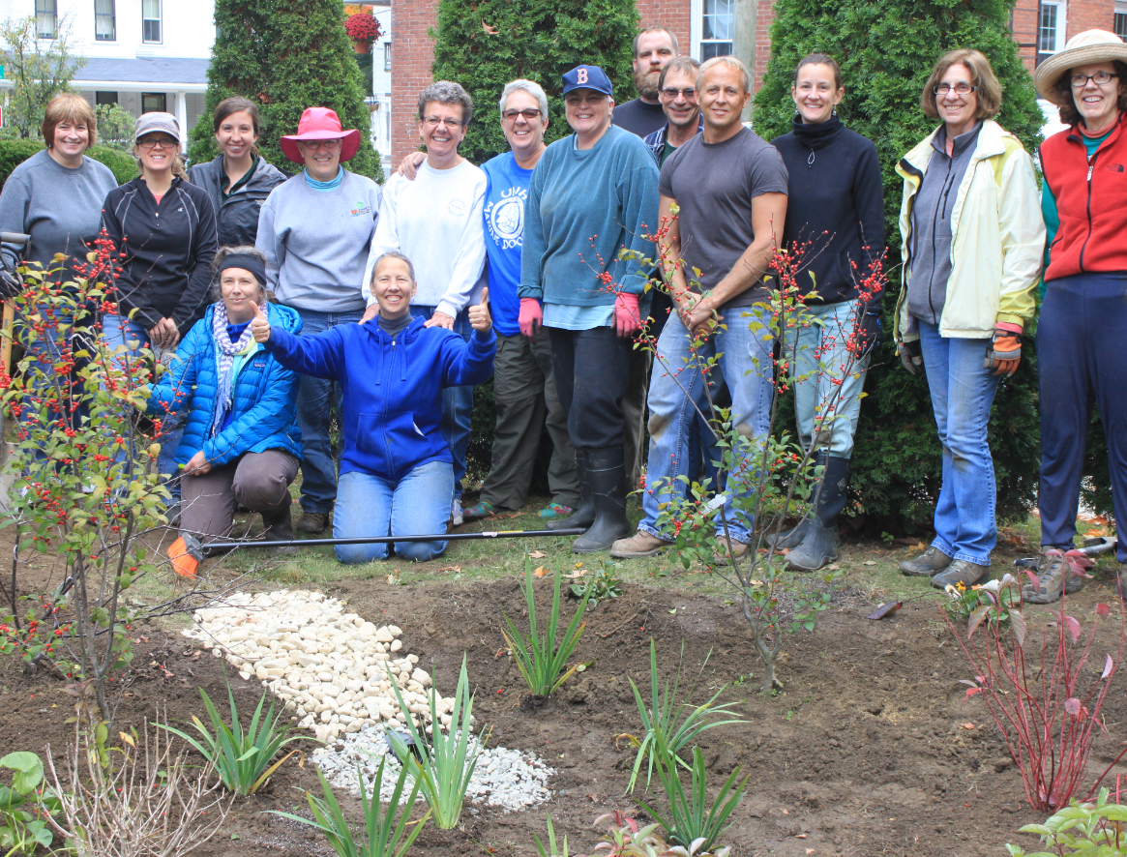
Local organizations or committees interested in stormwater-related or landscaping-related topics or work.
Specific Circumstances:
- Can be outreach material distribution, event and/or stormwater BMP installation.
- Good activity to partner with neighboring MS4s.
- Good activity to build relationships with partners.
Description:
Soak Up the Rain NH (SOAK) www.soaknh.org is a voluntary NHDES program that provides information about how our residential and small business properties create stormwater pollution and how to prevent it with rain gardens, infiltration trenches, and other practices. A municipality can participate in SOAK at any level: Distribute editable or standard SOAK outreach materials to your residents and small businesses on how they can reduce stormwater impacts from their properties; partner with local entities to host a SOAK educational event or training; and/or provide assistance (money or staff time) during a SOAK installation.
Cost:
Assistance is provided by NHDES free. Municipality or partner organization provides venue and refreshments. Installations usually require 50/50 match from homeowner or business and municipality. Total cost is estimated at $100 to $400 depending on type of BMP.
Timeline:
Outreach or event is best in winter or spring. BMP installations can be done in late spring, summer, or early fall. Installing vegetated BMPs during hot summer weather is not recommended.
Steps:
- Identify internal person to lead project or to get project started.
- May want to contact other MS4s in your area to partner with on training.
- Contact NHDES SOAK Coordinator at: Lisa.loosigian@des.nh.gov or 603-271-1190. Discuss how to participate and identify goals.
- Partner with local organization or committee, i.e., garden club, conservation commission, watershed or water quality organization, school environmental club.
  - If installation is desired outcome, work with partner to identify project lead and have them contact NHDES SOAK Coordinator at: Lisa.loosigian@des.nh.gov or 603-271-1190 to identify project goal(s) and type of installation(s).
- Distribute materials, promote and conduct event, and/or install BMP (with assistance from NHDES SOAK and partner).
Measurement Suggestions - (Choose from below or create your own measurement method(s)):
- Document type, date, target audience, and number of materials distributed.
- Document type, date, and audience attending event.
- If BMP is installed, document date, type, and participants of installation. Photograph before, during and after installation.

