Standard Operating Procedures for:
NH MS4 Permit Minimum Control Measure #1: Education and Outreach
Event: NHDES Project Wet Teacher or Volunteer Training

MS4 Requirement (Part III in NH Matrix):
Topic: General NPS Awareness
- Meets requirements for Resident, and Business and Institution audiences
- For municipalities or areas with no impairments or TMDLS (2 per audience per permit term)

Specific Audience:
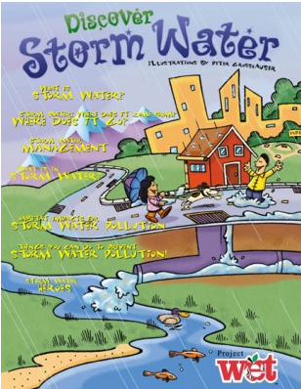
Schools (K-12 teachers or other educators)
Specific Circumstances:
- This is a good activity for someone who knows a teacher or has a connection at a local school.
- Good activity to partner with neighboring MS4s on.
- Can provide training to volunteers or DPW staff instead of teachers.
- Training can count as an effort and any events trained staff participate can count as additional efforts.
Description:
Project Wet is a water related training workshop for educators at a school or organization. The format is flexible and can occur on one day or over two days. WET workshops are conducted by trained facilitators throughout the year at various sites in New Hampshire. Interested schools, districts, and other organizations can request a WET workshop to be presented on-site. https://www.des.nh.gov/organization/divisions/water/dwgb/wet/index.htm
Cost:
Teachers and schools may need help with subsidizing part or all of training costs. NH Project WET charges $50 per participant ($35 for students). Other special rates and formats may be available so please contact your Project WET coordinator. Depending on your district, schools may also have costs associated with replacing the participating teacher with a substitute teacher (approximately $65).
Timeline:
Can schedule a regional training year round or participate in pre-scheduled training. Contact Laua.Hooper@des.nh.gov or 603-271-4071.
Steps:
- Identify internal person to lead project.
- May want to contact other MS4s in your area to partner with on training.
- Contact NHDES Project Wet Coordinator at: Lara.Hooper@des.nh.gov or 603-271-4071. Discuss: how to participate, any workshops planned already this year, and how to get started. Consider four options:
  - Consider assisting with training costs or providing local water quality information for the training. Identify approximately how many educators will attend to document in annual report. Check off as done.
  - Approach principal, administrative office manager, or science or other teachers – k-12 grade to see if they will be interested in participating in event.
  - Promote and provide school contacts with NHDES Project Wet contact information.
  - Send other municipal staff or volunteer to training.
- Confirm school will participate.
Measurement Suggestions - (Choose from below or create your own measurement method(s)):
- Document date of training and how many teachers, municipal staff or volunteers attend for annual report. (MS4 contacts NHDES)
- Check in with NHDES on any training participant evaluation results. (MS4 and NHDES)
- Later, track any events trained staff participate in (tours, visiting presentations, etc.) to count as additional MS4 outreach effort later. (MS4)

