Standard Operating Procedures for:
NH MS4 Permit Minimum Control Measure #1: Education and Outreach
Event: Industrial Audience Letter and Factsheet

MS4 Requirement (Part 1 in NH Matrix):
Topic: Industrial Audience understands steps to improve water quality.
- Meets requirements for Industrial audience
- For all municipalities (MS4s) (2 per permit term – 5 year)
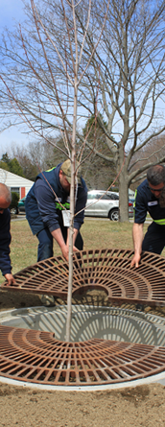
Specific Audience:
Industrial facilities located in MS4 community.
Specific Circumstances:
- Some MS4s might not have industrial facilities within their MS4 town boundaries. If this is the case, the MS4 would want to make note in both their NOI and SWMP. No additional outreach efforts are required if the MS4 has no industrial facilities.
- The permit only requires that an outreach effort is conducted for industrial facilities within MS4 boundaries but it is up to the MS4 themselves to decide if they want to reach out to all industrial facilities within their town boundaries instead.
Description:
Industrial Facilities Outreach Letter (located here), Stormwater Pollution Control for Industrial Facilities Fact Sheet (located here), Green SnowPro Brochure (located here) are the outreach materials that can be customized and sent out to industrial facilities. Industrial facilities within MS4 boundaries can be determined using the List of Industrial Facilities within MS4 Boundaries Sorted by Town (located here)
Cost:
- All of the outreach materials are located on the New Hampshire MS4 Blog and can be printed for free.
Timeline:
Any time of year.
Steps:
- Identify industrial facilities within MS4 boundaries using the List of Industrial Facilities within MS4 Boundaries Sorted by Town (located here).
- Think if there are any industrial facilities within your MS4 that were not on the List of Industrial Facilities within MS4 Boundaries Sorted by Town. If so, make sure to add them to your list of industrial facilities to reach out to.
- Customize and fill out the Industrial Facilities Outreach Letter (located here) and the Stormwater Pollution Control for Industrial Facilities Fact Sheet (located here).
- Send out the Industrial Facilities Outreach Letter, the Stormwater Pollution Control for Industrial Facilities Fact Sheet, and the Green SnowPro Brochure (located here) to all of the industrial facilities within your MS4 boundaries.
- Measure results (Measurement below).
Measurement Suggestions - (Choose from below or create your own measurement method(s)):
- Identify start date for tracking. Would most likely be the day the outreach materials were sent out.
- Track number of outreach materials sent out.

