Standard Operating Procedures for:
NH MS4 Permit Minimum Control Measure #1: Education and Outreach
Event: NHDES Water Fair and Water Festival

MS4 Requirement (Part III in NH Matrix):
Topic: General NPS Awareness
- Meets requirements for Resident, and Business and Institution audiences
- For municipalities or areas with no impairments or TMDLS (2 per audience per permit term)
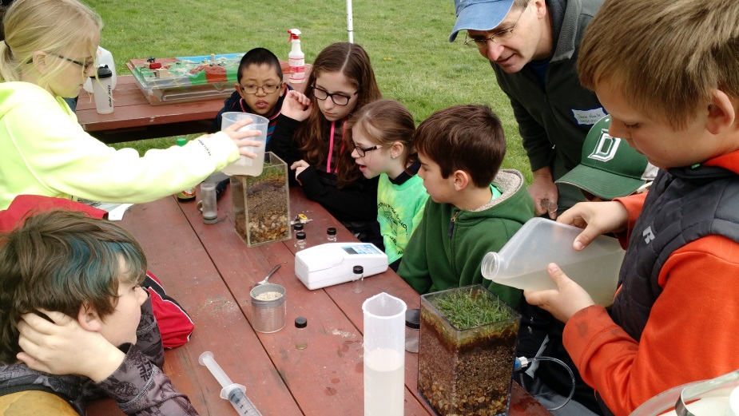
Specific Audience:
Schools – 4th Grade.
Specific Circumstances:
- This is a good event for someone who knows a teacher or has a connection at a local school.
- Your municipalities’ schools may already be participating in this event.
- NHDES is also looking for hosts for regional festivals.
Description:
The NHDES Water Fair (competition) and Water Festival is held every May for 4th grade students. It includes water and stormwater activities and demonstrations and a water science related competition.
Cost:
Free to participating schools. There may be related transportation (busing) costs.
Timeline:
Schools start planning for events at the beginning of the school year. Make first contacts (as early as possible) in September/October for the following May event.
Steps:
- Identify internal person to lead project.
- Contact NHDES Project Wet Coordinator at: Lara.Hooper@des.nh.gov or 603-271-4071. Discuss: how to participate, whether your school has participated before or plans to this year and if there are any contacts to recommend.
  - If school is already participating, consider assisting with transportation costs or providing volunteers for the event. Identify approximately how many students will attend to document in annual report. Check off as done.
  - If school is not planning to participate, follow remaining steps.
- Go to principals, or science teachers, or other teachers – 5th grade to see if they will be interested in participating in event.
- Provide school contacts with NHDES Project Wet contact information.
- Confirm school will participate.
- Following event, use template provided for local press release or posting on facebook or other town related social media.
Measurement Suggestions - (Choose from below or create your own measurement method(s)):
- Document how many students attend for annual report. (MS4 gets info from NHDES)

