Standard Operating Procedures for:
NH MS4 Permit Minimum Control Measure #1: Education and Outreach
Event: Developer Check List Materials and Posters

MS4 Requirement (Part 1 in NH Matrix):
Topic: Developers understand federal, state, and local regulations.
- Meets requirements for Developer audience
- For all municipalities (MS4s) (2 per permit term – 5 year)
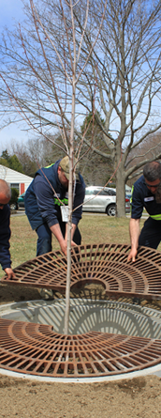
Specific Audience:
Developers or staff working for developers (consultants, engineers, landscape designers, etc.) doing business in MS4 community.
Specific Circumstances:
- Many MS4s may already address this requirement through existing site plan applications, or regulations or pre-construction check lists. Just need to reference and track number of applicants.
- If this messaging is already addressed through the local application, regulations or checklists, the municipality can report out on how many project applications they received this past permit year.
Description:
Pre-construction checklists from Dover (Located here), Site Plan Application checklist from Portsmouth (Located here), and Derry Construction Checklist (Located here) will provide examples to compare with your municipal resources and identify where to add a reference to General Construction Permit (GCP) and EPA GCP fact sheet (Located here).
Cost:
- EPA GCP fact sheet and posters are available for MS4 to print for free online.
Timeline:
Any time of year. Can use to track from implementation to Annual Report deadline (July 1st ).
Steps:
- Identify responsible party to set this up.
- Review checklist and other examples at: https://www4.des.state.nh.us/nh-ms4/?page_id=54 and scroll down to “MCM #1 – Part II Matrix: Developer and Industrial Audience” or contact Tom Swenson at: Thomas.Swenson@des.nh.gov or 603-271-7889.
- Confirm existence of CGP, local SW regulations, and/or state (Alteration of Terrain) references in your municipal checklists, applications, and/or regulations.
- Optional: Add reference to EPA GCP fact sheet (Located here) in existing or new pre-construction or other developer related checklists, i.e., “reviewed EPA General Construction Permit Fact Sheet.”
- Measure results (Measurement below).
Measurement Suggestions - (Choose from below or create your own measurement method(s)):
- Identify start date for tracking. Could be the beginning of the reporting year if messaging is already in municipal checklists, applications, and/or regulations.
- Track number of applications or developers met with.

