Septic System Maintenance Tips Social Media Posts

Post 1:
Text:
Just because something says its “flushable” doesn’t necessarily mean it’s safe for your septic system. Only toilet paper and human waste should be flushed down your toilet. Learn more here: https://getpumpednh.com #SepticSmartWeek #GetPumpedNH

Video or image:
Use the following video: https://www.youtube.com/watch?v=mcYAubOSEvc
Or
Use the following image:
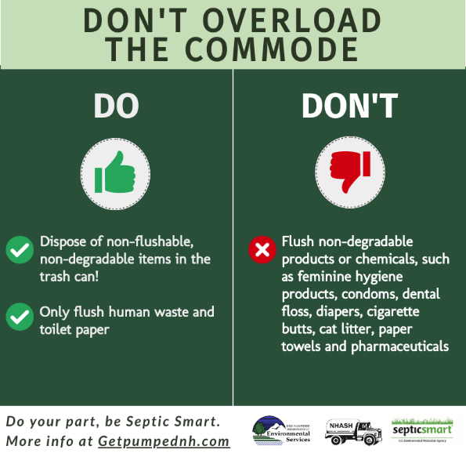

Post 2:
Text:
Getting your septic system pumped doesn’t just help to keep it functioning properly. It also helps your community stay safe by keeping waste water out of local waterbodies. Learn more here https://getpumpednh.com #SepticSmartWeek #GetPumpedNH

Image:
Use the following image:
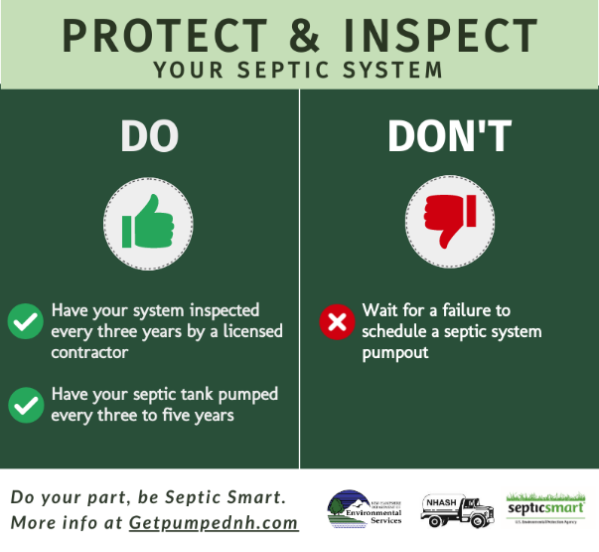

Post 3:
Text:
Did you know that the placement of trees and shrubs on your lawn can affect your septic system? Shield your field with these #SepticSmartWeek tips! #GetPumpedNH
Video or image:
Use the following video: https://www.youtube.com/watch?v=Q4bTQ0PQiJA
Or
Use the following image:
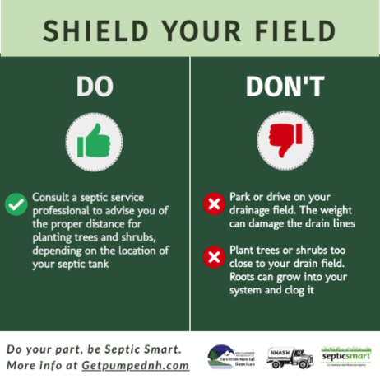

Post 4:
Text:
Water efficiency goes a long way when it comes to your septic system. Small leaks could mean big problems! #SepticSmartWeek #GetPumpedNH

Image:
Use the following image:
