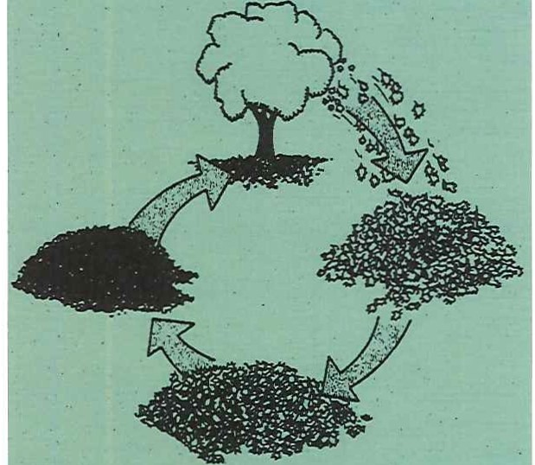
What is compost? What can I compost?

BACKYARD

Composting is nature's way of recycling. Composting is a natural process of decomposi­ tion of organic material into a rich soil amend­ ment.

The following lists are a guide to the types of materials that are good and not good to com­ post. To produce the best quality compost, material thicker than W' should be shredded or chopped.

USE DON'T USE

Nature's Way
of Recycling

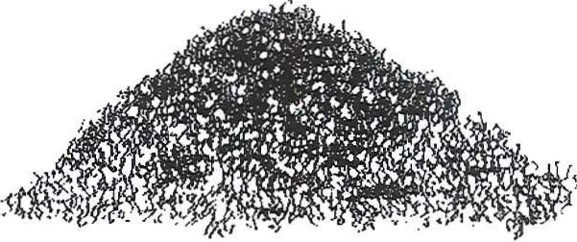
Why should I compost?
There are two basic reasons for composting. The primary reason people compost is to create a beneficial product from what is traditionally viewed as a waste. Gardeners have long known this secret. By composting leaf and yard waste, gardeners create a useful soil amendment to be incorporated into flower and vegetable gardens,

leaves
lawn clippings pine needles weeds
straw
hay sawdust wood ashes
shredded newspaper animal manures coffee grounds
fruits & vegetables crushed eggshells

meats bones
fatty foods oils
dairy products colored newspaper coal ashes
dog or cat wastes pressure treated
wood
plywood anything not bio­
degradable

from the N.H. Department of Environmental Services
used as a mulch around trees or as a top dress­
ing on lawns.
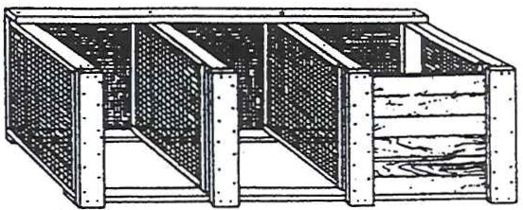
The second reason is that it is beneficial to the environment. Composting is done to reduce the amount of waste that makes its way to New Hampshire's landfills and incinerators.
How can I use compost?

Compost can be applied to enrich the flower and vegetable garden, to top-dress the lawn, and as mulch around trees and shrubs. House plants and planter boxes will benefit from combining compost with potting soil.
Before using, it's best to sift the compost through a 1/2" mesh hardware cloth. The remaining coarse material may then be put back into a new compost pile for further decomposition.
Heavy clay or light sandy soil will benefit most from the addition of compost. Apply a 2" layer on the soil surface and thoroughly work it into the upper six to eight inches of soil.

Biology
Organic waste material decomposes through the actions of the soil micro-organisms. They start the process of decaying matter by break­ ing down plant tissue. Soon, fungi and proto­ zoans join in and later centipedes, millipedes, beetles and earthworms do their part. These micro-organisms work best when sufficient oxygen, moisture and nitrogen are supplied.
Materials
Anything growing in the yard -leaves, weeds, grass clippings, kitchen waste (except meat, bones, dairy products, and fatty foods)-is potential food for the tiny micro-organisms working in the pile. Avoid using diseased
plant materials. Surface Area
Material decomposes faster if the micro­
organisms have more surfaces with which to work. Chopping garden waste with a shovel, running it through a shredding machine or lawnmower, speeds its composting.
Size
The ideal size for the pile is four feet wide and four feet high by any convenient length.

For more information

Smaller piles have trouble holding heat and larger piles may have aeration difficulties.
Moisture and Aeration
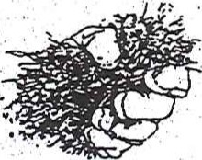
The microbes work best when the pile is as moist as a wrung-out sponge and has plenty of air passages. Too much sun will dry out the pile and too much water will make it soggy.
Time and Temperature
The hotter the pile, the faster the composting. Ideal composting temperatures range from
1002F-1402F. With proper amounts of water,
air, and materials, compost can be made in two to three months.
Carbon to Nitrogen Ratio
All living organisms need relatively large amounts of the element carbon (C) and smaller amounts of nitrogen (N). To speed
composting, combine carbon-rich "brown" materials such as leaves with nitrogen-rich "green" materials such as grass clippings. The ideal compost combination is 30 parts carbon to one part nitrogen.
What's wrong
with my compost?

Symptom: The compost has a bad odor. Problems: Not enough air; pile too wet. Solutions: Tum it; add coarse materials such as straw, com stalks, etc.

Symptom: The center of the pile is dry. Problems: Not enough water; too much woody material.
Solutions: Turn; moisten; add fresh green wastes; chop coarse wastes.

Symptoms: Compost is damp and warm only in the middle.
Problem: Pile too small.
Solutions: Get more material; mix old ingredients into a new pile.

Symptoms: The pile is damp and sweet­ smelling, but won't heat up.
Problem: Lack of nitrogen.
Solutions: Mix in a nitrogen source such as food waste, fresh grass clippings, fresh manure, bloodmeal or ammonium sulfate.

Symptoms: Pest problems-birds, animals, rats, dogs, etc.
Problem: Undesirable food wastes.
Solutions: Remove any fish, meats, bones or dairy products. Be sure to cover or bury
vegetable scraps.

Refer to the guide Composting to Reduce the Waste Stream published by the UNH Cooperative Exten­
sion and available at all New Hampshire public libraries. For more information, please contact the University of New Hampshire Cooperative Extension Family, Home and Garden Education Center toll-free at 877-398-4769, or contact the N.H. Department of Environmental Services, 29 Hazen
Drive, Concord, NH 03302-0095. Information is also available at your local lawn and garden centers.

Selecting a Method
Your compost pile can be a simple heap of materials in a comer of your yard, or a bin to help organize the pile and keep it from blowing around your yard. Ready-made and easy-to­ assemble bins can be purchased at local hard­ ware and garden supply stores. Many people prefer to use their own method or create a bin themselves. There are many different types of methods or units to choose from.

Heaps/Piles
What are they? Heap composting doesn't require a structure. It is simply a pile placed in your yard.
COMPOSTING YARD WASTES

Holding Units
What are they? Simple containers or bins that hold yard and garden waste until composting is complete.
How? Add organic material to the holding unit as it is generated. The composting process can be hastened by chopping or shredding organic materials, mixing high-nitrogen and high-carbon materials, maintaining proper moisture, or turning the pile.
Pros/Cons? Holding units are easily made and are a relatively inexpensive method of composting. Composting may take six months to two years, depending upon the organic materi­ als and conditions present.
Variations: Possible holding units are circles of wire fencing or hardware cloth, old wooden pallets wired or tied together, snow fencing or wire framed in wood. In any case, the unit

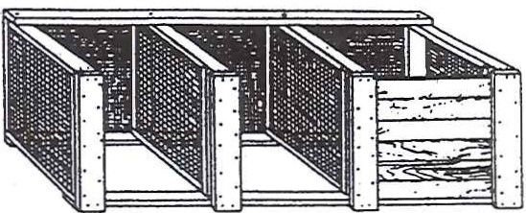

Turning Units
What are they? A series of three or more bins, or a rotating barrel/rolling ball that allows wastes to be turned regularly. This unit works well for gardeners with a large volume of yard waste, or for those requiring faster composting.
How? Layer alternately high-carbon and high­ nitrogen materials in a 30:1 ratio. Moisten to the damp sponge state. When the temperature of the pile decreases substantially, turn it into the next bin. Again, dampen if not moist and add high­
How? Combine organic materials together in a heap/pile measuring about five feet wide and three feet high. Materials may be added as they become available, or stockpiled until enough materials are available to make a good-sized heap. Water to the damp sponge stage. The pile may be turned regularly or not at all.
Pros/Cons? This is the least expensive method, but if no turning is done, composting will take many months.
Mulching
How? Spread leaves and grass clippings around the base of plants a few inches from the stem. Chipped woody waste can be used as mulch around trees and shrubs.
Pros/Cons? Yard waste works first as mulch then decomposes into a soil amendment. The disad­ vantage is you have to buy or rent power equipment to chip woody wastes.
Variations: Chipped materials can be used to make informal garden paths.
should be constructed to allow air transfer through the sides and back.
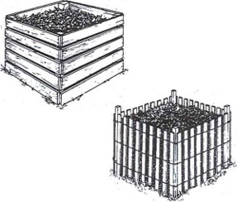
nitrogen material if heating doesn't occur. After
the pile heats and cools again, tum into the third
bin. The compost should be ready for use after two weeks in the third bin.
Pros/Cons? Produces a high-quality compost in a short time with a large amount of care and labor. Units may be expensive to build or buy.
Variations: Turning units may be built of wood, concrete blocks, or a combination of wood and wire. There are also barrel/rolling ball composters that tumble the wastes.

Where to find compost bins
Contact your local recycling center/transfer station or recycling committee about your town's involvement with the annual compost bin sale.
Compost bins can also be purchased from local home and garden centers.

