*Thank you for disposing of yard waste correctly!*

*Any questions?*

***Contact the DPW at 497-3617***

*Transfer station hours of operation: Tuesday through Saturday 7:30am to 3pm.*

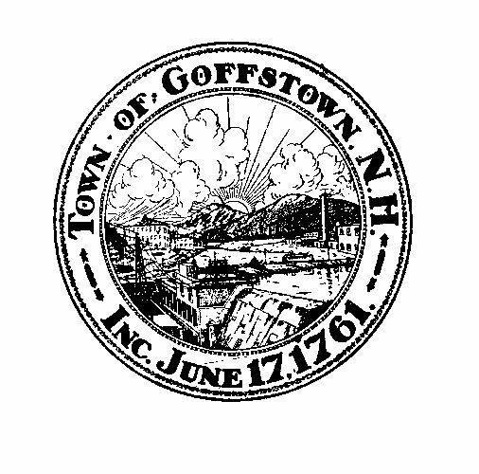

Congue nihil imperdiet doming id quod mazim placerat facer minim veni am ut wisi enim ad minimeniam, quis erat nostr uexe

rci tation ullamcorper nostru exerci tation ullam corper et iusto odio dig nissim qui blandit praesent lupta. Tummer delenit

augue duis dolore te feugait nulla facilisi. Con erattis sectetuer adip iscing elit, sed erat diam nonummy nibh magna erat.

***Goffstown DPW***

***Yard Waste***

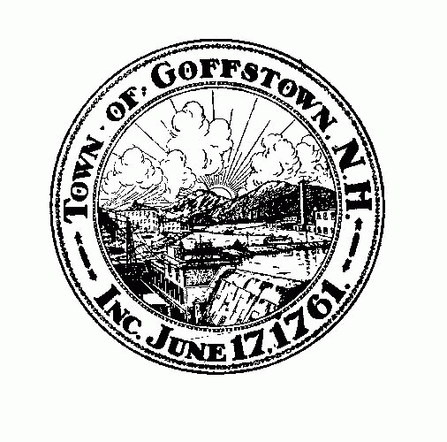

***Cartoon Leaf***

***Cartoon Leaf***

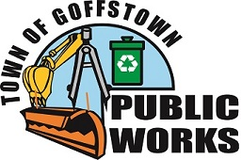

***Cartoon Leaf***

***Cartoon Leaf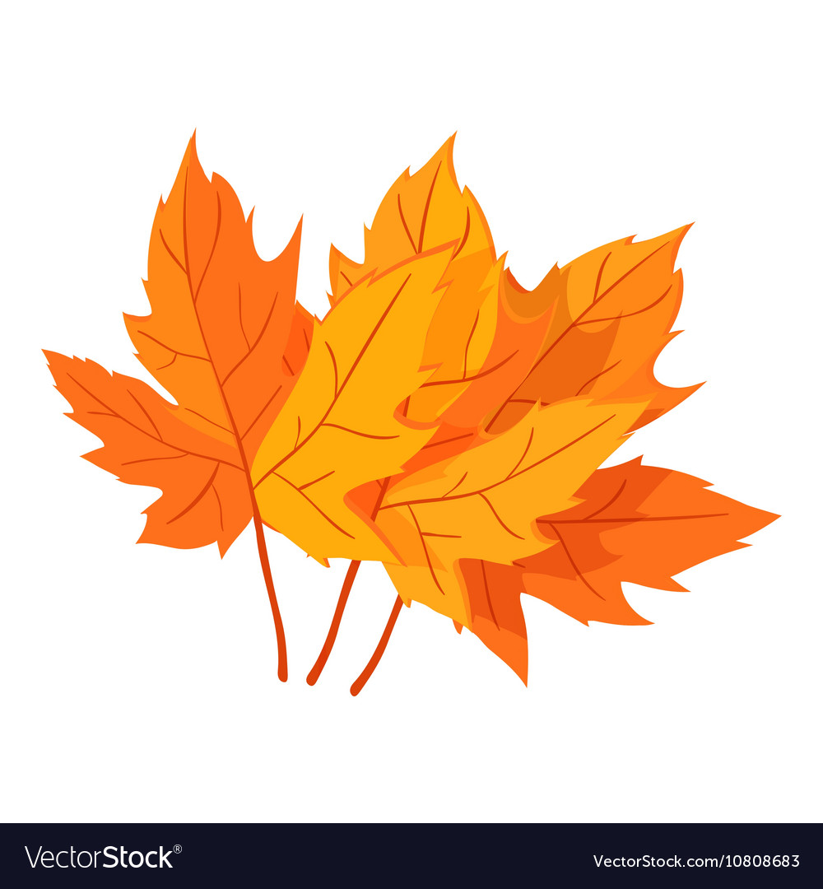Cartoon Leaf***

***Cartoon Leaf***

***Cartoon Leaf***





***Cartoon Leaf***

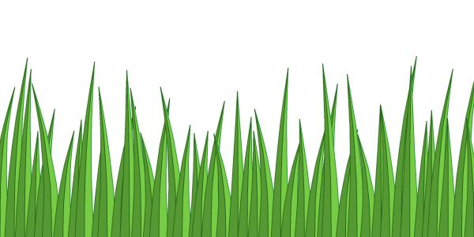

If at home composting isn’t for you,

please bring all of your yard waste to the Transfer Station in town to be disposed of correctly.

There is no road side pick up for yard waste.

**404 Elm St Goffstown, NH, 03045**

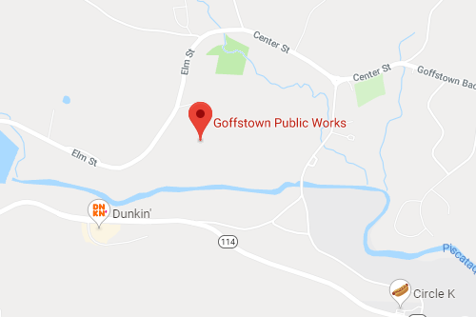

At the transfer station, all yard waste is composted, or recycled into barkmulch for the public.

*Where to Bring Your Yard Waste*

***Invasive Species***

While you are doing yard work, be aware of invasive species such as:

* Japanese Knotweed
* Burning Bush
* Giant Hogweed
* Autumn Olive

To know more about invasive plants, go to NH Department of Agriculture:

<https://www.agriculture.nh.gov/divisions/plant-industry/invasive-plants.htm>



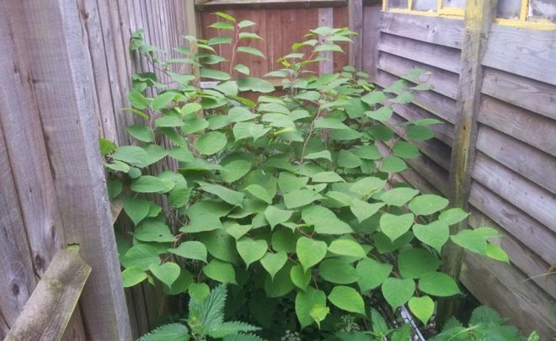

*What happens when you dispose of Yard Waste Incorrectly*

Do not put yard waste in the trash or recycling.

**Your barrel will not be picked up.**

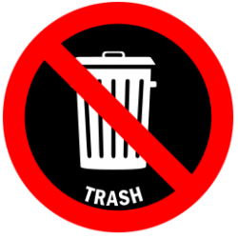

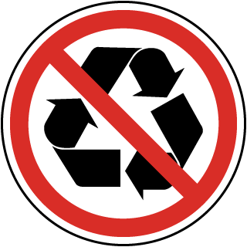

You can try at home composting, or bring your yard waste to the transfer station.

Visit this site for information on composting yard waste at home:

<https://www.pennlive.com/gardening/2016/10/how_to_compost_your_yard_waste.html>

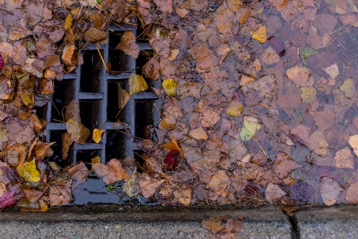

* If yard waste is left in your yard, wind and rain can carry it into the stormwater drainage system, where it could cause a blockage.
* Small amounts of yard waste in the recycling can contaminate a large portion of recyclables, which then need to be thrown away.
* Grass clippings contain fertilizers and pesticides that can contaminate rivers and lakes and contribute to their impairment.

