

WHY SHOULD I *PUMP?*

Every home generates wastewater – via toilets,

showers, sink drains, and dish and clothes washers which must be treated and disposed of properly to protect human health and the environment.

WHEN SHOULD I *PUMP?*

Don’t wait for a failure! Septic tanks should be inspected or pumped every *3-5 years*. Get Pumped today!

Only contact a NHDES-licensed septage hauler. Visit *getpumpednh.com* to find a New Hampshire Association of Septage Haulers (NHASH) member in your area.

COMMUNITY *MESSAGE*

Our community cares about clean water and is doing its part to help prevent water pollution in local waterways. This outreach message helps our community meet US Environmental Protection Agency (EPA) requirements (including as part of the MS4 program) to share pollution prevention information with its residents.

PROTECT YOUR *FAMILY*

If your septic system gets clogged with too much solid waste, it can force the wastewater to back up into your house. It can also overwhelm your leach field, which will turn your yard into a soggy mess. The bacteria in wastewater are not just smelly – they are also a health hazard!

PROTECT YOUR *COMMUNITY*

If a septic system fails, untreated wastewater can run off into local lakes, ponds or streams, negatively impacting water quality, wildlife and community enjoyment of the water body.

PROTECT YOUR *WALLET*

Getting your tank pumped costs about **$250-**

**$500** every **3-5 years**. If you have a failure, it could cost you **$6,000-$15,000** to **replace** or **repair** your system.



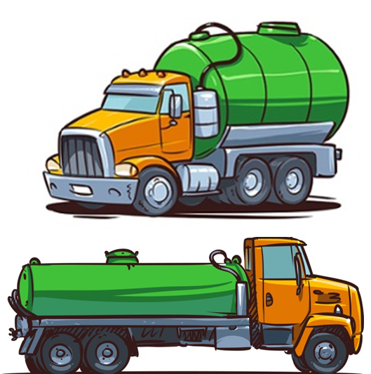



**GET PUMPED!**

*New Hampshire*

Don’t wait for a *failure* to schedule a septic system pumpout



**Town of Merrimack**

Department of Public Works

(DPW)

6 Baboosic Lake Road

Merrimack, NH

DO I HAVE A *SEPTIC SYSTEM?*

You most likely have a septic system if:

* + You are on well water and you don’t pay a water or sewer utility bill.
  + Your neighbors have septic systems.

HOW DO I FIND MY *SEPTIC?*

* + Check your yard for lids or manhole covers.
  + Contact a NHDES-licensed septage hauler to help you find the system. Find one here: https://www.des.nh.gov/sites/g/files/ehbemt341/files/documents/nh-permitted-septage-haulers.pdf
  + Request records through the NHDES Subsurface Systems File and Archive online form: [*https://onlineforms.*](https://onlineforms.nh.gov/?FormTag=NHDES-W-05-010)

[*nh.gov/?FormTag=NHDES-W-05-010*](https://onlineforms.nh.gov/?FormTag=NHDES-W-05-010)

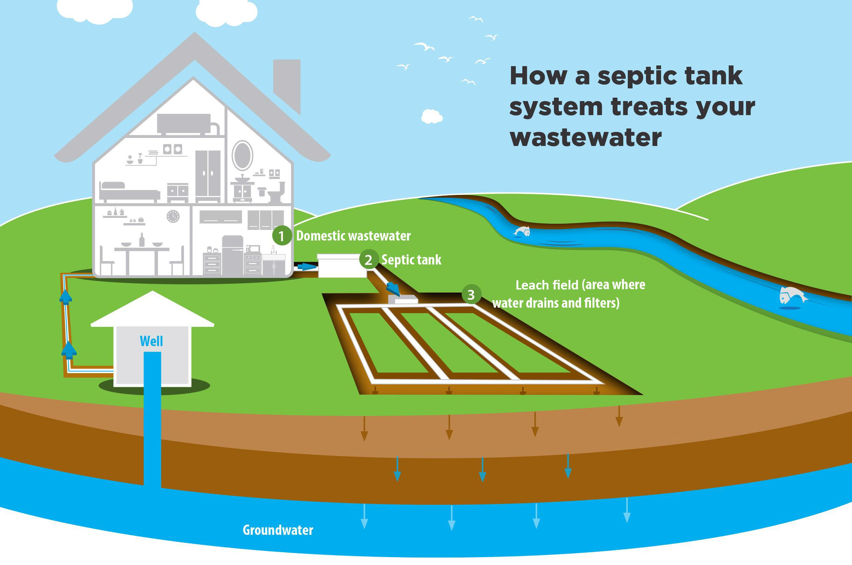

HOW DOES IT *WORK?*

*1*

.



source: unl.edu

[*nhash.com*](http://nhash.com/)

New Hampshire Association of Septage Haulers

*www.des.nh.gov*

SEPTIC SYSTEM *MAINTENANCE*

It’s not just about pumping! Here are every-day things you can do to help maintain your system.

* *Conserve water:* Fix leaky faucets and toilets to prevent washing away the healthy bacteria your system needs.
* *Space out water use:* Spreading out washing machine loads and other large water uses (showers, dishwashers, etc.) gives your system a chance to work between loads.
* *Only flush human waste and toilet paper:* “Flushable” may only mean that it fits down the drain...

**If in doubt, throw it out.**

* *Don’t park or drive on your system:* This can easily damage the septic system.

Whatever goes down the drain is your *domestic wastewater*. All drains in your house lead to one large drainage pipe that empties into your septic tank.

The *septic tank* is a buried, water-tight container, usually made of concrete or polyethelene. It holds the wastewater long enough for solids to settle to the bottom, while oils and grease float to the top. Special compartments keep the solids from flowing into the leach field.

Liquid wastewater leaves the tank and enters the *leach field*, where special pipes allow the water to slowly seep into the surrounding soil, naturally removing harmful bacteria, viruses and nutrients before it re-enters the groundwater.

*3*

*2*