Environmentally Friendly Lawn Tips Social Media Posts

- Want an easy and cost effective way to fertilize your lawn? Leaving your lawn clippings after mowing allows the nutrients in the cut grass to return to the soil. This allows for the grass to naturally fertilizer itself and cuts down on the need for additional fertilizers. To learn more tips on taking care of your lawn in an environmentally friendly way, please visit UNH Cooperative Extension’s website here https://extension.unh.edu/tags/home-lawn-care
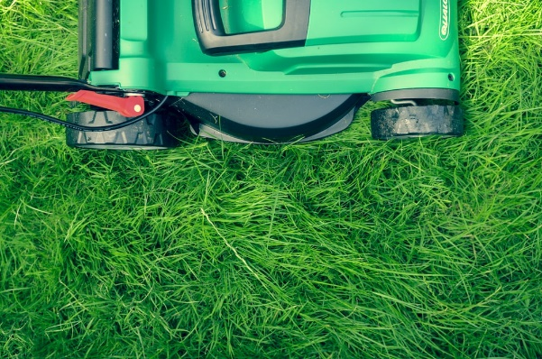

- Over applying fertilizer on your lawn can cause water quality issues in waterbodies around your home. Excess fertilizer that is not able to be absorbed by the lawn may be washed away during rain storms and eventually flows into rivers, lakes or, streams. This excess fertilizer can cause algae blooms or harm the animals living in the waterbody. Using fertilizers that are low in phosphorus or have slow release nitrogen are good options to both help keep your lawn looking great and help the environment at the same time. To learn more tips on taking care of your lawn in an environmentally friendly way, please visit UNH Cooperative Extension’s website here https://extension.unh.edu/tags/home-lawn-care
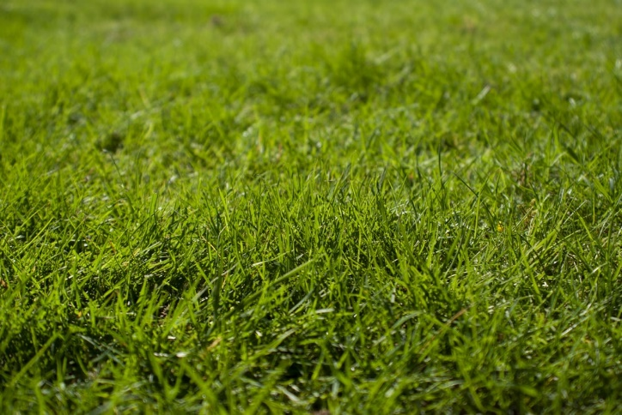

- Did you know that over watering your lawn can actually do more damage than good? Lawns only need about 1 inch of water each week. Too much watering can cause the nutrients in the soil, that the grass needs to stay healthy, to be washed away. These nutrients then flow into rivers, lakes, and streams where they can cause algae blooms or hurt the animals living in the water. To learn more tips on taking care of your lawn in an environmentally friendly way, please visit UNH Cooperative Extension’s website here https://extension.unh.edu/tags/home-lawn-care
