What you can do
What you can do

- Remove the bag from your lawnmower or use a mulching lawnmower. Leave the clippings to add organic matter and recycle nutrients, and avoid having to dispose of the grass clippings.

- Put yard waste on the curb in a paper bag or reusable, clearly marked “Yard Waste” container. (if your towns offers this)

- Drop off your yard waste at the Municipal Public Works for composting. Call Phone number for more information.

- Start backyard composting (away from surface waters). See: https://www.des.nh.gov/organization/divisions/waste/swrtas/documents/compost_flier.pdf for a free “how-to” brochure.

- NEVER dispose of leaves or clippings in or near storm drains, drainage channels (where water drains rain or melting snow), wetlands or waterbodies!

- Remove the bag from your lawnmower or use a mulching lawnmower. Leave the clippings to add organic matter and recycle nutrients, and avoid having to dispose of the grass clippings.

- Put yard waste on the curb in a paper bag or reusable, clearly marked “Yard Waste” container. (if your towns offers this)

- Drop off your yard waste at the Municipal Public Works for composting. Call Phone number for more information.

- Start backyard composting (away from surface waters). See: https://www.des.nh.gov/organization/divisions/waste/swrtas/documents/compost_flier.pdf for a free “how-to” brochure.

- NEVER dispose of leaves or clippings in or near storm drains, drainage channels (where water drains rain or melting snow), wetlands or waterbodies!

More Information

Town contact information.

NH Department of Environmental Services, 603-271-7889 or Thomas.D.Swenson@des.nh.gov

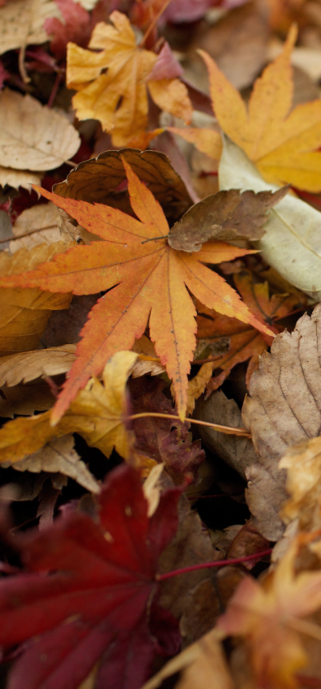

Rake it
or
Leave it

What to do with your leaves and grass clippings to protect New Hampshire Waters

Why Does it Matter?
You Choose - your leaves and grass clippings can be a valuable resource OR a source of water pollution.

Our Community Cares
Our community cares about clean water and is doing its part to help prevent water pollution in local waterways. This outreach message helps our community meet US Environmental Protection Agency (EPA) requirements to share pollution prevention information with its residents.

As a source of water pollution . . .
BAD

Decaying leaves and grass kill critters in streams, rivers, lakes, ponds, and wetlands.
Leaves and grass clippings decompose in water and wetlands by using the oxygen that other organisms such as dragonfly larvae, crabs, and fish need to live.

Yard waste on stream banks smothers natural vegetation.
Leaves or grass dumped near banks, shorelines and wetlands block sunlight and smother the natural plant life that provide food and cover to animals such as turtles, ducks, chipmunks, and deer.

Yard waste dumped near waterbodies contributes to stream algae and odors.
Seepage from yard waste piled on or near banks and shorelines will slowly make its way into the water. Algae then grow and form foul-smelling, green mats on the water surface.

Yard waste dumped in or near wetlands or surface waters is against the law!

In an effort to protect wetlands and surface waters, the NH legislature passed a law that prohibits filling streams and wetlands with waste materials, including yard waste. RSA 482-A:3

As a resource . . .
GOOD

Mulched leaves or grass clippings on your lawn add valuable nutrients and organic matter.
Grass clippings provide a source of slow-release nutrients reducing the amount of lawn fertilizer needed by at least half or none. A thin layer of leaves will break down and add much needed organic matter to plant beds.

Composting leaves and grass clippings save money.
Compost is natural recycling. Compost can be used as a top dressing on your lawn or garden beds reducing or eliminating the need for fertilizer and mulch.

TOWN CITY WATERBODY MAP OR PHOTO
.

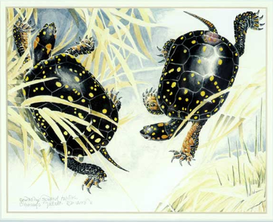
Produced by the NH Department of Environmental Services 603-271-7889

Distributed by the
MUNICIPAL INFO
MUNICIPAL LOGO

